# Lab 1: Creating a Simple Webpage

In this lab, you’ll demonstrate HTML development concepts and best practices.

## Instructions

1. In a folder called /Lab1, create a file called index.html and a folder called images. Your project structure must match this exactly:  
   Graphical user interface, text

   Description automatically generated
2. In the index.html file, using only HTML, re-create a web page that contains the content described below.
3. Submission instructions:
   1. Install the application 7-zip. Download the application here: <https://www.7-zip.org/>
   2. In Windows File Explorer, right-click the folder Lab1, and choose 7-Zip -> Add to “Lab1.zip”

* 1. Upload the file Lab1.zip to Brightspace.

1. Submit your lab by the due date listed in Brightspace. See the marking criteria below for details on how you will be assessed.

**Page Content**

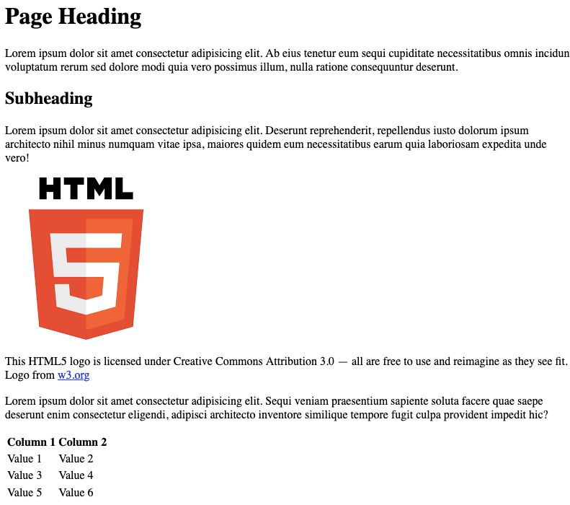

© 2022, Southern Alberta Institute of Technology

**Notes:**

* Generate placeholder text using your text editor or any lorem ipsum generator.
* The HTML logo is available from <https://www.w3.org/html/logo>.

## Marking Criteria

|  |  |  |  |  |
| --- | --- | --- | --- | --- |
|  | **0 Marks** | **1 Mark** | **2 Marks** | **Marks** |
| **HTML Syntax** | No HTML is submitted. | Code is visible on the page. | Page renders without visible errors. | /2 |
| **HTML Syntax** | No HTML is submitted. | HTML has syntax errors. | HTML passes validation with no errors. | /2 |
| **Images** | No image tag element is included. | The image does not appear. | Image renders on page. | /2 |
| **Accessibility** | No images are included. | One or more images are missing alt-text. | All images have descriptive alt-text. | /2 |
| **Linking** | No anchors are included. | Anchor does not work. | Anchor correctly links to another website. | /2 |
| **Tables** | Table is not included. | Table does not render correctly. | Webpage includes a table. | /2 |
| **Tables** | Table is not included. | Inappropriate table elements were used. | Table uses correct elements. | /2 |
| **Tables** | Table is not included. | Table borders are visible | Table matches sample | /2 |
| **Heading** | Use of heading tag missing | Heading tag not used correctly | Heading tags are used. | /2 |
| **Paragraph** | Paragraph tags are not used | Only one paragraph tag is used in webpage | Paragraph tags are used. | /2 |
| **Reference** | Image reference missing | Image reference included but not correct | Image reference is included | /2 |
| **Use of HTML** | Used JavaScript to style page | Used CSS to style page | HTML only is used to create webpage. | /2 |
| **Output** | Output doesn’t match with the given sample output | Output varies from the sample output | Output must match sample output. | /2 |
| **HTML Attributes** | No HTML is submitted. | Obsolete HTML elements are included. | Appropriate HTML elements are used. | /2 |
| **Total** |  |  |  | /28 |